# BUILDING MATERIALS

**Building material** is material used for [construction](https://en.wikipedia.org/wiki/Construction). Many naturally occurring substances, such as [clay](https://en.wikipedia.org/wiki/Clay), rocks, sand, [wood](https://en.wikipedia.org/wiki/Wood), and even twigs and leaves, have been used to construct [buildings](https://en.wikipedia.org/wiki/Building). Apart from naturally occurring materials, many man-made products are in use, some more and some less synthetic. The manufacturing of building materials is an established industry in many countries and the use of these materials is typically segmented into specific specialty trades, such as [carpentry](https://en.wikipedia.org/wiki/Carpentry), [insulation](https://en.wikipedia.org/wiki/Building_insulation), [plumbing](https://en.wikipedia.org/wiki/Plumbing), and [roofing](https://en.wikipedia.org/wiki/Roofing_material) work. They provide the make-up of [habitats](https://en.wikipedia.org/wiki/Category:Human_habitats) and [structures](https://en.wikipedia.org/wiki/Architecture) including [homes](https://en.wikipedia.org/wiki/Home).

Some of the Building Materials

1. Sand 10. Timber
2. Wood 11. Granite
3. Glass 12. Gravel
4. Cement
5. Steel
6. Plastic
7. Brick
8. Concrete
9. Aggregates

# ****Sand****

# What Is Fine Aggregate | Types of Fine Aggregates (Classification) Aggregate Sand Manufacturer,Aggregate Sand Exporter & Supplier in Bharuch India

# Introduction

**Sand** is a type of naturally occurring [material](https://www.designingbuildings.co.uk/wiki/Materials) that is of a granular, [loose](https://www.designingbuildings.co.uk/wiki/Loo), [fragmented](https://www.designingbuildings.co.uk/wiki/Fragmented) composition, consisting of particulate matter such as [rock](https://www.designingbuildings.co.uk/wiki/Rock), coral, [shells](https://www.designingbuildings.co.uk/wiki/Shell), and so on. **Sand** is typically finer than [gravel](https://www.designingbuildings.co.uk/wiki/Gravel) but coarser than [silt](https://www.designingbuildings.co.uk/wiki/Silt).

The [precise](https://www.designingbuildings.co.uk/wiki/Precise) composition of **sand** varies depending on its source and the [conditions](https://www.designingbuildings.co.uk/wiki/Condition) prevalent at that [location](https://www.designingbuildings.co.uk/wiki/Location). In in-[land](https://www.designingbuildings.co.uk/wiki/Land) continental [regions](https://www.designingbuildings.co.uk/wiki/Region), the predominant constituent of **sand** is [silica](https://www.designingbuildings.co.uk/wiki/Silica) ([silicon](https://www.designingbuildings.co.uk/wiki/Silicon) dioxide), typically in the [form](https://www.designingbuildings.co.uk/wiki/Form) of [quartz](https://www.designingbuildings.co.uk/wiki/Quartz). **Sand** that has been created over millions of years by such things as coral and shellfish is typically [aragonite](https://www.designingbuildings.co.uk/wiki/Aragonite), which is a [form](https://www.designingbuildings.co.uk/wiki/Form) of [calcium carbonate](https://www.designingbuildings.co.uk/wiki/Calcium_carbonate).

# Uses of ****sand****

**Sand** is very commonly used in [construction](https://www.designingbuildings.co.uk/wiki/Construction), often providing bulk, [strength](https://www.designingbuildings.co.uk/wiki/Strength), and stability to other [materials](https://www.designingbuildings.co.uk/wiki/Materials) such as [asphalt](https://www.designingbuildings.co.uk/wiki/Asphalt), [concrete](https://www.designingbuildings.co.uk/wiki/Concrete), [mortar](https://www.designingbuildings.co.uk/wiki/Mortar), [render](https://www.designingbuildings.co.uk/wiki/Render), [cement](https://www.designingbuildings.co.uk/wiki/Cement), and [screed](https://www.designingbuildings.co.uk/wiki/Screed). **Sand** is also used as a base [layer](https://www.designingbuildings.co.uk/wiki/Layer) is known as ‘[blinding](https://www.designingbuildings.co.uk/wiki/Blinding)’, which is laid above a [layer](https://www.designingbuildings.co.uk/wiki/Layer) of [hardcore](https://www.designingbuildings.co.uk/wiki/Hardcore" \o "Hardcore) to provide a clean, [level](https://www.designingbuildings.co.uk/wiki/Level), and dry surface for [construction works](https://www.designingbuildings.co.uk/wiki/Construction_works). It can also be used in its raw [form](https://www.designingbuildings.co.uk/wiki/Form) as a decorative [material](https://www.designingbuildings.co.uk/wiki/Materials) in [landscaping](https://www.designingbuildings.co.uk/wiki/Landscaping).

**Sand** is used in liquid [form](https://www.designingbuildings.co.uk/wiki/Form) to [manufacture](https://www.designingbuildings.co.uk/wiki/Manufacture) [glass](https://www.designingbuildings.co.uk/wiki/Glass) and is also used for molding [metal](https://www.designingbuildings.co.uk/wiki/Metal) casting. It can be used as an abrasive in the process of sandblasting which cleans [structural elements](https://www.designingbuildings.co.uk/wiki/Structural_element), [steelwork](https://www.designingbuildings.co.uk/wiki/Steelwork), and so on. Sandpaper is also made using sand.

## Manufacture

Manufactured sand (M sand) is sand made from rock by artificial processes, usually for construction purposes in cement or concrete. It differs from river sand by being more angular, and has somewhat different properties.

## Resources and environmental concerns

Only some sands are suitable for the construction industry, for example for making [concrete](https://en.wikipedia.org/wiki/Concrete). Because of the growth of population and of cities and the consequent construction activity there is a huge demand for these special kinds of sand, and natural sources are running low. In 2012 French director [Denis Delestrac](https://en.wikipedia.org/wiki/Denis_Delestrac) made a documentary called "[Sand Wars](https://en.wikipedia.org/wiki/Sand_Wars)" about the impact of the lack of construction sand. It shows the ecological and economic effects of both legal and illegal trade in construction sand.[[18]](https://en.wikipedia.org/wiki/Sand#cite_note-18)[[19]](https://en.wikipedia.org/wiki/Sand#cite_note-19)[[20]](https://en.wikipedia.org/wiki/Sand#cite_note-20)

To retrieve the sand, the method of hydraulic dredging is used. This works by pumping the top few meters of sand out of the water and filling it into a boat, which is then transported back to land for processing. Unfortunately, all [marine life](https://en.wikipedia.org/wiki/Marine_life) mixed in with the extracted sand is killed and the ecosystem can continue to suffer for years after the mining is complete. Not only does this affect marine life, but also the local fishing industries because of the loss of life, and communities living close to the water's edge. When sand is taken out of the water it increases the risk of landslides, which can lead to loss of agricultural land and/or damage to dwellings.[[21]](https://en.wikipedia.org/wiki/Sand#cite_note-21)

Sand's many uses require a significant [dredging](https://en.wikipedia.org/wiki/Dredging) industry, raising environmental concerns over fish depletion, landslides, and flooding.[[22]](https://en.wikipedia.org/wiki/Sand#cite_note-22) Countries such as China, Indonesia, Malaysia, and Cambodia ban sand exports, citing these issues as a major factor.[[23]](https://en.wikipedia.org/wiki/Sand#cite_note-23) It is estimated that the annual consumption of sand and gravel is 40 billion tons and sand is a US$70 billion global industry.[[24]](https://en.wikipedia.org/wiki/Sand#cite_note-24) With increasing use, more is expected to come from recycling and alternatives to sand.

# Aggregate

**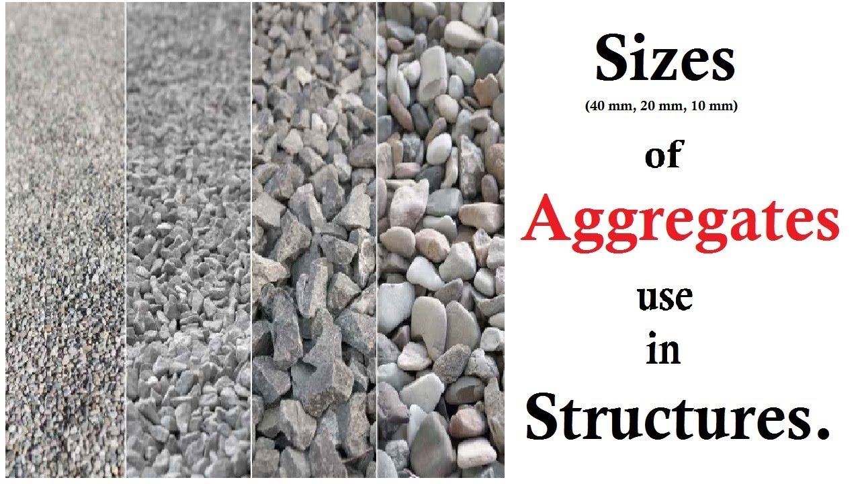**

# Introduction

**Aggregate** is the term given to [material](https://www.designingbuildings.co.uk/wiki/Materials) frequently used in [construction](https://www.designingbuildings.co.uk/wiki/Construction) as a means of stabilising and [reinforcement](https://www.designingbuildings.co.uk/wiki/Reinforcement). **Aggregates** are widely used in [drainage](https://www.designingbuildings.co.uk/wiki/Drainage) applications and as base [material](https://www.designingbuildings.co.uk/wiki/Materials) under [foundations](https://www.designingbuildings.co.uk/wiki/Foundations) and [roads](https://www.designingbuildings.co.uk/wiki/Road). In the 10 years ending in 2010, 2.5 billion tonnes of **aggregates** were consumed by the [UK](https://www.designingbuildings.co.uk/wiki/UK). These **aggregates** were [supplied](https://www.designingbuildings.co.uk/wiki/Supplied) from various sources:

# The largest source is from quarrying of the [land](https://www.designingbuildings.co.uk/wiki/Land) for [sand](https://www.designingbuildings.co.uk/wiki/Sand) and [gravel](https://www.designingbuildings.co.uk/wiki/Gravel), or for [rock](https://www.designingbuildings.co.uk/wiki/Rock) suitable for crushing (mainly [limestone](https://www.designingbuildings.co.uk/wiki/Limestone), [sandstone](https://www.designingbuildings.co.uk/wiki/Sandstone), and [igneous rock](https://www.designingbuildings.co.uk/wiki/Igneous_rock), but also some unusually hard occurrences of chalk, [ironstone](https://www.designingbuildings.co.uk/wiki/Iron), [slate](https://www.designingbuildings.co.uk/wiki/Slate), etc.).

# [Sand](https://www.designingbuildings.co.uk/wiki/Sand) and [gravel](https://www.designingbuildings.co.uk/wiki/Gravel) is dredged from the seabed and is a regionally significant source

# Uses

As a basic raw [material](https://www.designingbuildings.co.uk/wiki/Materials) **aggregates** can be put to many uses, although certain tasks may require a specific type of **aggregate**. A large proportion of **aggregate** is used to [manufacture](https://www.designingbuildings.co.uk/wiki/Manufacture) [concrete](https://www.designingbuildings.co.uk/wiki/Concrete), as well as the [cement](https://www.designingbuildings.co.uk/wiki/Cement) that is used in the [concrete](https://www.designingbuildings.co.uk/wiki/Concrete).

**Aggregates** are used in [construction](https://www.designingbuildings.co.uk/wiki/Construction) to provide [drainage](https://www.designingbuildings.co.uk/wiki/Drainage), fill voids, protect [pipes](https://www.designingbuildings.co.uk/wiki/Pipe), and to provide hard surfaces.

**Aggregates** are not just used for [construction](https://www.designingbuildings.co.uk/wiki/Construction). A vast array of other [products](https://www.designingbuildings.co.uk/wiki/Products), many of which are taken for granted, are [manufactured](https://www.designingbuildings.co.uk/wiki/Manufactured) using [materials](https://www.designingbuildings.co.uk/wiki/Materials) derived from quarrying. These include: paper, [glass](https://www.designingbuildings.co.uk/wiki/Glass), cosmetics and toothpaste to name but a few. **Aggregates** are also used in [agriculture](https://www.designingbuildings.co.uk/wiki/Agriculture), food [manufacture](https://www.designingbuildings.co.uk/wiki/Manufacture), and [water](https://www.designingbuildings.co.uk/wiki/Water) and [sewage](https://www.designingbuildings.co.uk/wiki/Sewage) purification. [Water](https://www.designingbuildings.co.uk/wiki/Water) will percolate through a [trench](https://www.designingbuildings.co.uk/wiki/Trenches) filled with **aggregate** more quickly than it will through the surrounding [soil](https://www.designingbuildings.co.uk/wiki/Soil), thus enabling an [area](https://www.designingbuildings.co.uk/wiki/Area) to be drained of [surface water](https://www.designingbuildings.co.uk/wiki/Surface_water). This is frequently used alongside [roads](https://www.designingbuildings.co.uk/wiki/Road) in [order](https://www.designingbuildings.co.uk/wiki/Order) to disperse [water](https://www.designingbuildings.co.uk/wiki/Water) collected from the [asphalt](https://www.designingbuildings.co.uk/wiki/Asphalt) surfacing.

Voids created around the [foundations](https://www.designingbuildings.co.uk/wiki/Foundations) of [buildings](https://www.designingbuildings.co.uk/wiki/Building) during [construction](https://www.designingbuildings.co.uk/wiki/Construction) are filled with **aggregate** because it is easier to compact than the original [soil](https://www.designingbuildings.co.uk/wiki/Soil) that was removed, resulting in a more solid [finish](https://www.designingbuildings.co.uk/wiki/Finishes) that will support the [structure](https://www.designingbuildings.co.uk/wiki/Structure). **Aggregates** generally are not affected by the [weather](https://www.designingbuildings.co.uk/wiki/Weather) as much as [soils](https://www.designingbuildings.co.uk/wiki/Soil), particularly [clay](https://www.designingbuildings.co.uk/wiki/Clay) [soils](https://www.designingbuildings.co.uk/wiki/Soil), and will not suffer from shrinkage [cracking](https://www.designingbuildings.co.uk/wiki/Cracking) during dry spells.

[Pipes](https://www.designingbuildings.co.uk/wiki/Pipe) laid to convey [treated water](https://www.designingbuildings.co.uk/wiki/Treated_water), or as [conduits](https://www.designingbuildings.co.uk/wiki/Conduit) for [cables](https://www.designingbuildings.co.uk/wiki/Cable), need to be protected from sharp objects in the [ground](https://www.designingbuildings.co.uk/wiki/Ground) and are therefore laid on, and surrounded by, fine **aggregate** before [trenches](https://www.designingbuildings.co.uk/wiki/Trenches) are [backfilled](https://www.designingbuildings.co.uk/wiki/Backfilled).

Unpaved [roads](https://www.designingbuildings.co.uk/wiki/Road) and [parking](https://www.designingbuildings.co.uk/wiki/Parking) [areas](https://www.designingbuildings.co.uk/wiki/Area) are covered in a surface [layer](https://www.designingbuildings.co.uk/wiki/Layer) of **aggregate** to provide a more solid surface for [vehicles](https://www.designingbuildings.co.uk/wiki/Vehicle), from bicycles to lorries. This prevents the [vehicles](https://www.designingbuildings.co.uk/wiki/Vehicle) from sinking into the [soil](https://www.designingbuildings.co.uk/wiki/Soil), particularly during wet [weather](https://www.designingbuildings.co.uk/wiki/Weather).

Concrete

# 23 Types of Concrete Used in Construction and their Applications - The Constructor What is Concrete - Civil Engineers PK

# Introduction

**Concrete** is the most commonly used man-made [material](https://www.designingbuildings.co.uk/wiki/Materials) on [earth](https://www.designingbuildings.co.uk/wiki/Earth). It is an important [construction material](https://www.designingbuildings.co.uk/wiki/Construction_materials) used extensively in [buildings](https://www.designingbuildings.co.uk/wiki/Building), [bridges](https://www.designingbuildings.co.uk/wiki/Bridge), [roads](https://www.designingbuildings.co.uk/wiki/Road) and [dams](https://www.designingbuildings.co.uk/wiki/Dam). Its uses range from [structural](https://www.designingbuildings.co.uk/wiki/Structural) applications, to [paviours](https://www.designingbuildings.co.uk/wiki/Paviour" \o "Paviour), [kerbs](https://www.designingbuildings.co.uk/wiki/Kerbs), [pipes](https://www.designingbuildings.co.uk/wiki/Pipe) and [drains](https://www.designingbuildings.co.uk/wiki/Drains).

**Concrete** is a [composite material](https://www.designingbuildings.co.uk/wiki/Composite_material), consisting mainly of [Portland cement](https://www.designingbuildings.co.uk/wiki/Portland_cement), [water](https://www.designingbuildings.co.uk/wiki/Water) and [aggregate](https://www.designingbuildings.co.uk/wiki/Aggregate) ([gravel](https://www.designingbuildings.co.uk/wiki/Gravel), [sand](https://www.designingbuildings.co.uk/wiki/Sand) or [rock](https://www.designingbuildings.co.uk/wiki/Rock)). When these [materials](https://www.designingbuildings.co.uk/wiki/Materials) are mixed together, they [form](https://www.designingbuildings.co.uk/wiki/Form) a workable paste which then gradually hardens over time.

# [Benefits](https://www.designingbuildings.co.uk/wiki/Benefit) of ****concrete****

There are numerous positive aspects of **concrete**:

* It is a relatively cheap [material](https://www.designingbuildings.co.uk/wiki/Materials) and has a relatively long [life](https://www.designingbuildings.co.uk/wiki/Life) with few [maintenance](https://www.designingbuildings.co.uk/wiki/Maintenance) requirements.
* It is strong in [compression](https://www.designingbuildings.co.uk/wiki/Compression).
* Before it hardens it is a very pliable substance that can easily be shaped.
* It is [non-combustible](https://www.designingbuildings.co.uk/wiki/Non-combustible).

# Characteristics of ****concrete****

The characteristics of **concrete** are determined by the [aggregate](https://www.designingbuildings.co.uk/wiki/Aggregate) or [cement](https://www.designingbuildings.co.uk/wiki/Cement) used, or by the method that is used to produce it. The water-to-[cement](https://www.designingbuildings.co.uk/wiki/Cement) ratio is the determining [factor](https://www.designingbuildings.co.uk/wiki/Factor) in ordinary [structural](https://www.designingbuildings.co.uk/wiki/Structural) **concrete** with a lower [water](https://www.designingbuildings.co.uk/wiki/Water) content resulting in a stronger **concrete**.

This, however, reduces the workability (and pumpability) of the **concrete**, which can be [measured](https://www.designingbuildings.co.uk/wiki/Measured) using the [slump test](https://www.designingbuildings.co.uk/wiki/Slump_test). The grading, shape, texture and proportion of [aggregate](https://www.designingbuildings.co.uk/wiki/Aggregate) can also have a similar affect. If a particularly strong **concrete** is required, the amount of [aggregate](https://www.designingbuildings.co.uk/wiki/Aggregate) can be reduced in relation to the [cement](https://www.designingbuildings.co.uk/wiki/Cement). However, [cement](https://www.designingbuildings.co.uk/wiki/Cement) is a significant [cost](https://www.designingbuildings.co.uk/wiki/Cost) [factor](https://www.designingbuildings.co.uk/wiki/Factor), and increasing its proportion in the mix will increase the overall [price](https://www.designingbuildings.co.uk/wiki/Price).

# Cement

# Cement, its nature and origin Cement - International Materials

# Introduction

**Cement** is a substance used for binding and hardening other [materials](https://www.designingbuildings.co.uk/wiki/Materials). [Water](https://www.designingbuildings.co.uk/wiki/Water) and **cement** set and harden through a chemical reaction known as '[hydration](https://www.designingbuildings.co.uk/wiki/Hydration)'. The process of hardening is described as '[curing](https://www.designingbuildings.co.uk/wiki/Curing)', which requires particular [conditions](https://www.designingbuildings.co.uk/wiki/Condition) of [temperature](https://www.designingbuildings.co.uk/wiki/Temperature) and [humidity](https://www.designingbuildings.co.uk/wiki/Humidity).

**Cement** can be mixed with a fine [aggregate](https://www.designingbuildings.co.uk/wiki/Aggregate) and [water](https://www.designingbuildings.co.uk/wiki/Water) to produce [mortar](https://www.designingbuildings.co.uk/wiki/Mortar), used in [masonry construction](https://www.designingbuildings.co.uk/wiki/Masonry_construction) as a [bedding](https://www.designingbuildings.co.uk/wiki/Bedding) and [adhesive](https://www.designingbuildings.co.uk/wiki/Adhesives) to bind and fill the gaps between adjacent [blocks](https://www.designingbuildings.co.uk/wiki/Block) of [brick](https://www.designingbuildings.co.uk/wiki/Brick), [concrete](https://www.designingbuildings.co.uk/wiki/Concrete) or [stone](https://www.designingbuildings.co.uk/wiki/Stone).

It can be also be mixed with [water](https://www.designingbuildings.co.uk/wiki/Water), [aggregates](https://www.designingbuildings.co.uk/wiki/Aggregate) (such as [gravel](https://www.designingbuildings.co.uk/wiki/Gravel), [sand](https://www.designingbuildings.co.uk/wiki/Sand) or [rock](https://www.designingbuildings.co.uk/wiki/Rock)), and sometimes [admixtures](https://www.designingbuildings.co.uk/wiki/Admixture), to [form](https://www.designingbuildings.co.uk/wiki/Form) [concrete](https://www.designingbuildings.co.uk/wiki/Concrete), and can be used to make [renders](https://www.designingbuildings.co.uk/wiki/Render), [screeds](https://www.designingbuildings.co.uk/wiki/Screed) and so on. The ratio of [water](https://www.designingbuildings.co.uk/wiki/Water) and **cement** will determine the overall [strength](https://www.designingbuildings.co.uk/wiki/Strength) and [quality](https://www.designingbuildings.co.uk/wiki/Quality) of the mix.

The exact [properties](https://www.designingbuildings.co.uk/wiki/Property) of the **cement** paste are very important:

* It must be fluid enough for some time after mixing to allow the mix to be formed into its final shape.
* It must then set and gain [strength](https://www.designingbuildings.co.uk/wiki/Strength) so that it binds the [aggregates](https://www.designingbuildings.co.uk/wiki/Aggregate) together to produce a strong [material](https://www.designingbuildings.co.uk/wiki/Materials).

# [Types of cement](https://www.designingbuildings.co.uk/wiki/Types_of_cement)

## [Portland cement](https://www.designingbuildings.co.uk/wiki/Portland_cement)

## Low [heat](https://www.designingbuildings.co.uk/wiki/Heat) blast-[furnace](https://www.designingbuildings.co.uk/wiki/Furnace) [Portland cement](https://www.designingbuildings.co.uk/wiki/Portland_cement)

## Rapid hardening **cement**

## Sulphate resisting **cement**

## [High alumina cement](https://www.designingbuildings.co.uk/wiki/High_alumina_cement)

## [Ferro-cement](https://www.designingbuildings.co.uk/wiki/Ferro-cement)

# Glass

# DOE Develops Flexible Glass Material That Is Stronger Than Steel Glass As A Building Material | 11 Types Of Glass Used In Construction | Advantages Of Glass | Disadvantages Of Glass | Properties Of Glass - Civiconcepts

# Introduction

[Glass](https://www.designingbuildings.co.uk/wiki/Glass) is a [material](https://www.designingbuildings.co.uk/wiki/Materials) made from liquid [sand](https://www.designingbuildings.co.uk/wiki/Sand). It is the name given to any amorphous (non-crystalline) solid that displays a [glass](https://www.designingbuildings.co.uk/wiki/Glass) transition near its melting [point](https://www.designingbuildings.co.uk/wiki/Points) which is around 1,700°C (3,090°F). This means that [materials](https://www.designingbuildings.co.uk/wiki/Materials) transform from a hard and brittle state into a molten state, or vice versa depending on whether the [glass](https://www.designingbuildings.co.uk/wiki/Glass) transition [temperature](https://www.designingbuildings.co.uk/wiki/Temperature) is the melting or solidifying [point](https://www.designingbuildings.co.uk/wiki/Points). An amorphous solid has some of the crystalline [order](https://www.designingbuildings.co.uk/wiki/Order) of a solid and some of the random molecular [structure](https://www.designingbuildings.co.uk/wiki/Structure) of a liquid.

Silicate [glass](https://www.designingbuildings.co.uk/wiki/Glass) is the most [common](https://www.designingbuildings.co.uk/wiki/Common) [form](https://www.designingbuildings.co.uk/wiki/Form), which consists mainly of silica or [silicon](https://www.designingbuildings.co.uk/wiki/Silicon) dioxide, SiO2. Impurities or additional [elements](https://www.designingbuildings.co.uk/wiki/Element) and compounds added to the silicate to change the color and other [properties](https://www.designingbuildings.co.uk/wiki/Property) of the [glass](https://www.designingbuildings.co.uk/wiki/Glass).

[Glass](https://www.designingbuildings.co.uk/wiki/Glass) is a very commonly used [material](https://www.designingbuildings.co.uk/wiki/Materials) because, whilst still molten, it can be manipulated into [forms](https://www.designingbuildings.co.uk/wiki/Form) suitable for a very wide range of different uses, from [packaging](https://www.designingbuildings.co.uk/wiki/Packaging) and [household](https://www.designingbuildings.co.uk/wiki/Household) objects to car [windscreens](https://www.designingbuildings.co.uk/wiki/Wind), [windows](https://www.designingbuildings.co.uk/wiki/Window), and so on.

# [Properties](https://www.designingbuildings.co.uk/wiki/Property) of [glass](https://www.designingbuildings.co.uk/wiki/Glass)

The composition of [glass](https://www.designingbuildings.co.uk/wiki/Glass) and the [cooling](https://www.designingbuildings.co.uk/wiki/Cooling) [rate](https://www.designingbuildings.co.uk/wiki/Rates) can be varied to give a range of [properties](https://www.designingbuildings.co.uk/wiki/Property) depending on the [end use](https://www.designingbuildings.co.uk/wiki/End_use) required:

* Visual [transparency](https://www.designingbuildings.co.uk/wiki/Transparency) and reflectance can be altered with the addition of [admixtures](https://www.designingbuildings.co.uk/wiki/Admixture) to the initial batch mix. [Glass](https://www.designingbuildings.co.uk/wiki/Glass) can be [transparent](https://www.designingbuildings.co.uk/wiki/Transparent), translucent, tinted, reflective, [stained](https://www.designingbuildings.co.uk/wiki/Stained), opaque, and so on.
* Solar [optical properties](https://www.designingbuildings.co.uk/wiki/Optical_properties) can be controlled to transmit, [absorb](https://www.designingbuildings.co.uk/wiki/Absorb) or reflect specific [wavelengths](https://www.designingbuildings.co.uk/wiki/Wavelength) of the [solar spectrum](https://www.designingbuildings.co.uk/wiki/Solar_spectrum).
* Long wave infra-red [optical properties](https://www.designingbuildings.co.uk/wiki/Optical_properties) can be varied to affect [emissivity](https://www.designingbuildings.co.uk/wiki/Emissivity), for example to create [low-e glass](https://www.designingbuildings.co.uk/wiki/Low-e_glass).
* [U value](https://www.designingbuildings.co.uk/wiki/U_values) can be altered by the [R-value](https://www.designingbuildings.co.uk/wiki/R-value) of [layers](https://www.designingbuildings.co.uk/wiki/Layer) of [glass](https://www.designingbuildings.co.uk/wiki/Glass) and their surface [heat transfers](https://www.designingbuildings.co.uk/wiki/Heat_transfer).
* [Strength](https://www.designingbuildings.co.uk/wiki/Strength) can be altered with [laminates](https://www.designingbuildings.co.uk/wiki/Laminate) and [admixtures](https://www.designingbuildings.co.uk/wiki/Admixture) that increase the ability of [glass](https://www.designingbuildings.co.uk/wiki/Glass) to resist deformation, shearing or shattering under [load](https://www.designingbuildings.co.uk/wiki/Loads).
* [Glass](https://www.designingbuildings.co.uk/wiki/Glass) can be worked in many different ways, from blowing, [drawing](https://www.designingbuildings.co.uk/wiki/Drawings) and pressing to [welding](https://www.designingbuildings.co.uk/wiki/Welding).
* [Glass](https://www.designingbuildings.co.uk/wiki/Glass) is 100% recyclable. Scraps of [waste](https://www.designingbuildings.co.uk/wiki/Waste) [glass](https://www.designingbuildings.co.uk/wiki/Glass) are used as raw [materials](https://www.designingbuildings.co.uk/wiki/Materials) in [glass](https://www.designingbuildings.co.uk/wiki/Glass) [manufacture](https://www.designingbuildings.co.uk/wiki/Manufacture) and as [aggregates](https://www.designingbuildings.co.uk/wiki/Aggregate) in [concrete](https://www.designingbuildings.co.uk/wiki/Concrete) [manufacture](https://www.designingbuildings.co.uk/wiki/Manufacture). The number of times [glass](https://www.designingbuildings.co.uk/wiki/Glass) has been recycled does not affect its [quality](https://www.designingbuildings.co.uk/wiki/Quality), [strength](https://www.designingbuildings.co.uk/wiki/Strength) or functionality

Wood

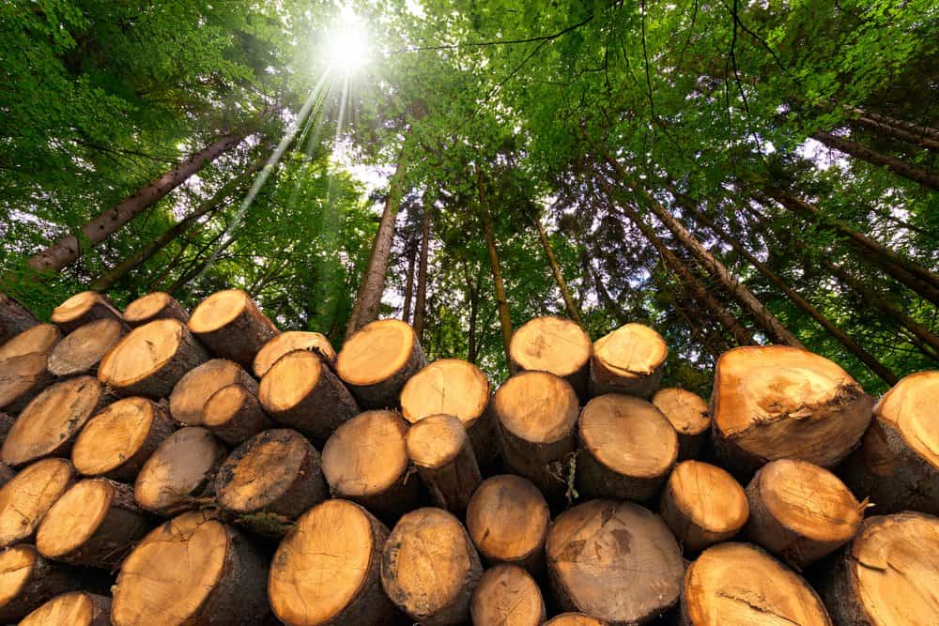 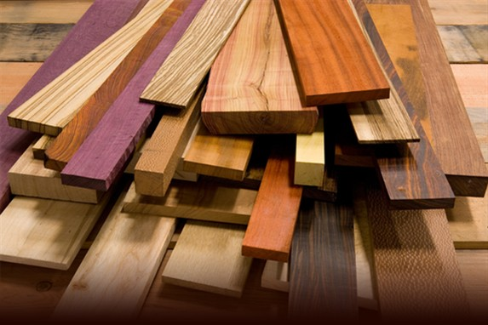

Wood is one of the most used natural building materials in the world. A number of valuable properties such as low heat conductivity, small bulk density, relatively high strength, amenability to mechanical working etc. makes wood as famous building material. The use of wood can reduce construction costs by up to 30%, with a low index of material waste, and speed up construction, spending half the time used in masonry construction. The wood can be applied in finishings, as concrete forms and as structural pieces, from lumber, squares and logs.

**Performance Properties**

Wood performance is dependent on a wide range of characteristics, the importance of which depends on how the piece is intended to be used.

* Strength
* stiffness
* Hardness
* Finish
* Retention
* Treatability with Preservatives
* Resistance to shrinkage, swelling, warping, checking weathering decay photodegradation color changes insect attack

## Uses of Wood in Different Sectors

Wood is a plant part having multipurpose uses those are impossible to deny and difficult to note all in our daily life. From the ancient time wood is used by human and this continuation still remains in the modern civilization. A few of many uses of wood are mentioned below:

### Construction and Fencing Sports Equipment

### Household Uses Art Industry

### Commercial Uses

# Steel

**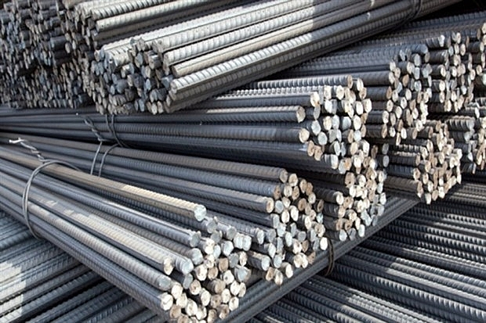** **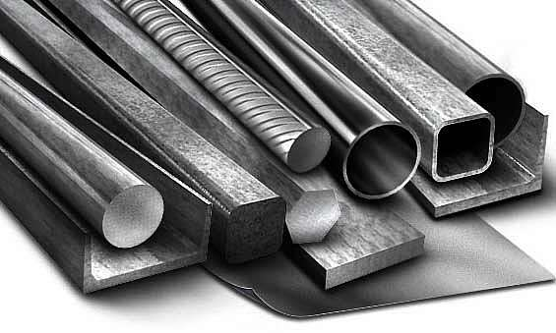**

**Steel** is an [alloy](https://en.wikipedia.org/wiki/Alloy) made up of [iron](https://en.wikipedia.org/wiki/Iron) with typically a few tenths of a percent of [carbon](https://en.wikipedia.org/wiki/Carbon) to improve its [strength](https://en.wikipedia.org/wiki/Strength_of_materials) and [fracture resistance](https://en.wikipedia.org/wiki/Fracture_toughness) compared to other forms of iron. Many other elements may be present or added. Stainless steels that are [corrosion](https://en.wikipedia.org/wiki/Corrosion)- and oxidation-resistant need typically an additional 11% [chromium](https://en.wikipedia.org/wiki/Chromium). Because of its high [tensile strength](https://en.wikipedia.org/wiki/Ultimate_tensile_strength) and low cost, steel is used in [buildings](https://en.wikipedia.org/wiki/Building), [infrastructure](https://en.wikipedia.org/wiki/Infrastructure), [tools](https://en.wikipedia.org/wiki/Tool), [ships](https://en.wikipedia.org/wiki/Ship), [trains](https://en.wikipedia.org/wiki/Train), [cars](https://en.wikipedia.org/wiki/Car), [machines](https://en.wikipedia.org/wiki/Machine), [electrical appliances](https://en.wikipedia.org/wiki/Home_appliance), and [weapons](https://en.wikipedia.org/wiki/Weapon). Iron is the [base metal](https://en.wikipedia.org/wiki/Base_metal) of steel. Depending on the temperature, it can take two crystalline forms (allotropic forms): [body-centred cubic and face-centred cubic](https://en.wikipedia.org/wiki/Cubic_crystal_system). The interaction of the [allotropes of iron](https://en.wikipedia.org/wiki/Allotropes_of_iron) with the alloying elements, primarily carbon, gives steel and [cast iron](https://en.wikipedia.org/wiki/Cast_iron) their range of unique properties.

In pure iron, the [crystal structure](https://en.wikipedia.org/wiki/Crystal_lattice) has relatively little resistance to the iron atoms slipping past one another, and so pure iron is quite [ductile](https://en.wikipedia.org/wiki/Ductility), or soft and easily formed. In steel, small amounts of carbon, other elements, and inclusions within the iron act as hardening agents that prevent the movement of [dislocations](https://en.wikipedia.org/wiki/Dislocation).

The carbon in typical steel alloys may contribute up to 2.14% of its weight.[[1]](https://en.wikipedia.org/wiki/Steel#cite_note-1) Varying the amount of carbon and many other alloying elements, as well as controlling their chemical and physical makeup in the final steel (either as solute elements, or as precipitated phases), impedes the movement of the dislocations that make pure iron ductile, and thus controls and enhances its qualities. These qualities include the [hardness](https://en.wikipedia.org/wiki/Hardness), [quenching behaviour](https://en.wikipedia.org/wiki/Quenching), need for [annealing](https://en.wikipedia.org/wiki/Annealing_(metallurgy)), [tempering behaviour](https://en.wikipedia.org/wiki/Tempering_(metallurgy)), [yield strength](https://en.wikipedia.org/wiki/Yield_(engineering)), and [tensile strength](https://en.wikipedia.org/wiki/Ultimate_tensile_strength) of the resulting steel. The increase in steel's strength compared to pure iron is possible only by reducing iron's ductility.

### Properties[[edit](https://en.wikipedia.org/w/index.php?title=Steel&action=edit&section=4" \o "Edit section: Properties)]

The [density](https://en.wikipedia.org/wiki/Density) of steel varies based on the alloying constituents but usually ranges between 7,750 and 8,050 kg/m3 (484 and 503 lb/cu ft), or 7.75 and 8.05 g/cm3 (4.48 and 4.65 oz/cu in).[[7]](https://en.wikipedia.org/wiki/Steel#cite_note-7)

Even in a narrow range of concentrations of mixtures of carbon and iron that make steel, several different metallurgical structures, with very different properties can form. Understanding such properties is essential to making quality steel. At [room temperature](https://en.wikipedia.org/wiki/Room_temperature), the most stable form of pure iron is the [body-centred cubic](https://en.wikipedia.org/wiki/Body-centred_cubic) (BCC) structure called alpha iron or α-iron. It is a fairly soft metal that can dissolve only a small concentration of carbon, no more than 0.005% at 0 °C (32 °F) and 0.021 wt% at 723 °C (1,333 °F). The inclusion of carbon in alpha iron is called [ferrite](https://en.wikipedia.org/wiki/Allotropes_of_iron). At 910 °C, pure iron transforms into a [face-centred cubic](https://en.wikipedia.org/wiki/Face-centred_cubic) (FCC) structure, called gamma iron or γ-iron. The inclusion of carbon in gamma iron is called austenite. The more open FCC structure of austenite can dissolve considerably more carbon, as much as 2.1%[[8]](https://en.wikipedia.org/wiki/Steel#cite_note-8) (38 times that of ferrite) carbon at 1,148 °C (2,098 °F), which reflects the upper carbon content of steel, beyond which is cast iron.[[9]](https://en.wikipedia.org/wiki/Steel#cite_note-9) When carbon moves out of solution with iron, it forms a very hard, but brittle material called cementite (Fe3C).

### Uses

### Long steel

* As reinforcing bars and mesh in reinforced concrete
* Railroad tracks
* Structural steel in modern buildings and bridges
* Wires
* Input to reforging applications

### Flat carbon steel[

* Major appliances
* Magnetic cores
* The inside and outside body of automobiles, trains, and ships.

### Weathering steel (COR-TEN)

* Intermodal containers
* Outdoor sculptures
* Architecture
* Highliner train cars

### Stainless steel

* Cutlery
* Rulers
* Surgical instruments
* Watches
* Guns
* Rail passenger vehicles
* Tablets
* Trash Can
* Body piercing jewellery
* Inexpensive rings
* Components of spacecraft and space stations

### Low-background steel

Steel manufactured after World War II became [contaminated](https://en.wikipedia.org/wiki/Radioactive_contamination) with [radionuclides](https://en.wikipedia.org/wiki/Radionuclide) by [nuclear weapons testing](https://en.wikipedia.org/wiki/Nuclear_weapons_testing). Low-background steel, steel manufactured prior to 1945, is used for certain radiation-sensitive applications such as [Geiger counters](https://en.wikipedia.org/wiki/Geiger_counter) and [radiation shielding](https://en.wikipedia.org/wiki/Radiation_shielding).

# Plastic

### Plastics: Building Material 20th Century - DIGIVILLAPLANS - plastics How Are Plastic Parts Changing the Construction Industry?

### Plastics are a wide range of [synthetic](https://en.wikipedia.org/wiki/Synthetic_polymers) or semi-synthetic materials that use [polymers](https://en.wikipedia.org/wiki/Polymer) as a main ingredient. Their [plasticity](https://en.wikipedia.org/wiki/Plasticity_(physics)) makes it possible for plastics to be [moulded](https://en.wikipedia.org/wiki/Injection_moulding), [extruded](https://en.wikipedia.org/wiki/Extrusion) or [pressed](https://en.wikipedia.org/wiki/Compression_molding) into solid objects of various shapes. This adaptability, plus a wide range of other properties, such as being lightweight, durable, flexible, and inexpensive to produce, has led to its widespread use. Plastics typically are made through human industrial systems. Most modern plastics are derived from [fossil fuel-based chemicals](https://en.wikipedia.org/wiki/Petrochemical) like [natural gas](https://en.wikipedia.org/wiki/Natural_gas) or [petroleum](https://en.wikipedia.org/wiki/Petroleum); however, recent industrial methods use variants made from renewable materials, such as [corn](https://en.wikipedia.org/wiki/Corn) or [cotton](https://en.wikipedia.org/wiki/Cotton) derivatives.

## Merits

* Plastics are strong yet lightweight, and so they are easy to transport & manoeuvre.
* They are durable, knock-and scratch resistant with excellent weatherability.
* They do not rot or corrode.
* Plastics are easy to install; many have a snap-fit kind of jointing procedures.
* Plastics offer limitless possibilities in design achieved by extrusion, bending, moulding etc.
* They can be given any range of colours by adding pigments.
* The plastics are low conductors of heat and thus are used as insulation materials in green building concepts.
* The plastics products can achieve tight seals.
* Plastic doesn't break easily
* They can be sawn and nailed employing standard carpentry tools and skills.
* They can be easily removed and recycled.
* They are poor conductors of electricity.

## Disadvantages and limitations

* Plastics may be degraded under the action of direct sunlight which reduces their mechanical strength.
* Many plastics are flammable unless treated.
* High embodied energy content
* Low modulus of elasticity: makes them unsuitable for load-bearing applications.
* Thermoplastics are subject to creep and soften at moderate temperatures.
* Thermal expansion for most plastics is high: adequate thermal movement has to be allowed in detailing.
* Many types of plastics are not biodegradable thus cause pollution when they accumulate.

## Products

Some of the examples below are Products of Plastics in the Construction industry:

* Pipes  : Electrical Conduits, Rain Water & Sewage pipes, Plumbing, Gas Distributions.
* Cables : PVC Insulation on cables, Insulation Tapes .
* Floorings : Flooring tiles & Rolls .
* Domes / sky lights : Opaque as well as transparent.
* Roofing  : Coloured or Double skinned for insulation.
* Windows & doors : Extruded sections for Door and windows and panels.
* Storage tanks : Storage tanks.
* Hardware accessories : Washers, Nut bolts, Sleeves, Anchoring wires.

# Brick

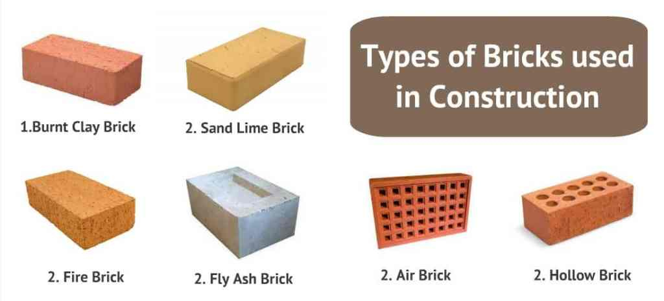 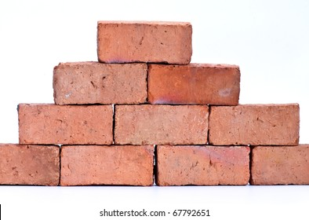

A **brick** is a type of block used to build walls, pavements and other elements in [masonry](https://en.wikipedia.org/wiki/Masonry) construction. Properly, the term *brick* denotes a block composed of dried [clay](https://en.wikipedia.org/wiki/Clay), but is now also used informally to denote other chemically cured construction blocks. Bricks can be joined using [mortar](https://en.wikipedia.org/wiki/Mortar_(masonry)), adhesives or by interlocking them.[[1]](https://en.wikipedia.org/wiki/Brick#cite_note-1)[[2]](https://en.wikipedia.org/wiki/Brick#cite_note-2) Bricks are produced in numerous classes, types, materials, and sizes which vary with region and time period, and are produced in bulk quantities.

[*Block*](https://en.wikipedia.org/wiki/Concrete_masonry_unit) is a similar term referring to a rectangular building unit composed of similar materials, but is usually larger than a brick. Lightweight bricks (also called lightweight blocks) are made from [expanded clay aggregate](https://en.wikipedia.org/wiki/Expanded_clay_aggregate).

Fired bricks are one of the longest-lasting and strongest [building materials](https://en.wikipedia.org/wiki/Building_material), sometimes referred to as artificial stone, and have been used since circa 4000 BC. Air-dried bricks, also known as [mudbricks](https://en.wikipedia.org/wiki/Mudbrick" \o "Mudbrick), have a history older than fired bricks, and have an additional ingredient of a mechanical binder such as straw.

Bricks are laid in *courses* and numerous patterns known as *bonds*, collectively known as [brickwork](https://en.wikipedia.org/wiki/Brickwork), and may be laid in various kinds of [mortar](https://en.wikipedia.org/wiki/Mortar_(masonry)) to hold the bricks together to make a durable structure.

## Uses

In the United States, bricks have been used for both buildings and pavements. Examples of brick use in buildings can be seen in colonial era buildings and other notable structures around the country. Bricks have been used in pavements especially during the late 19th century and early 20th century. The introduction of asphalt and concrete reduced the use of brick pavements, but they are still sometimes installed as a method of [traffic calming](https://en.wikipedia.org/wiki/Traffic_calming) or as a decorative surface in [pedestrian precincts](https://en.wikipedia.org/wiki/Pedestrianized_zone). For example, in the early 1900s, most of the streets in the city of [Grand Rapids](https://en.wikipedia.org/wiki/Grand_Rapids), [Michigan](https://en.wikipedia.org/wiki/Michigan), were paved with bricks. Today, there are only about 20 blocks of brick-paved streets remaining (totalling less than 0.5 percent of all the streets in the city limits).[[33]](https://en.wikipedia.org/wiki/Brick#cite_note-33) Much like in Grand Rapids, municipalities across the United States began replacing brick streets with inexpensive [asphalt concrete](https://en.wikipedia.org/wiki/Asphalt_concrete) by the mid-20th century.[[34]](https://en.wikipedia.org/wiki/Brick#cite_note-34)

Bricks in the [metallurgy](https://en.wikipedia.org/wiki/Metallurgy) and [glass](https://en.wikipedia.org/wiki/Glass) industries are often used for lining [furnaces](https://en.wikipedia.org/wiki/Metallurgical_furnace), in particular [refractory](https://en.wikipedia.org/wiki/Refractory) bricks such as [silica](https://en.wikipedia.org/wiki/Silica), [magnesia](https://en.wikipedia.org/wiki/Periclase), [chamotte](https://en.wikipedia.org/wiki/Grog_(clay)" \o "Grog (clay)) and neutral ([chromomagnesite](https://en.wikipedia.org/w/index.php?title=Chromomagnesite&action=edit&redlink=1" \o "Chromomagnesite (page does not exist))) [refractory bricks](https://en.wikipedia.org/wiki/Fire_brick). This type of brick must have good [thermal shock](https://en.wikipedia.org/wiki/Thermal_shock) resistance, refractoriness under load, high melting point, and satisfactory [porosity](https://en.wikipedia.org/wiki/Porosity). There is a large refractory [brick industry](https://en.wikipedia.org/w/index.php?title=Brick_industry&action=edit&redlink=1), especially in the United Kingdom, Japan, the United States, Belgium and the Netherlands.

In Northwest Europe, bricks have been used in construction for centuries. Until recently, almost all houses were built almost entirely from bricks. Although many houses are now built using a mixture of [concrete blocks](https://en.wikipedia.org/wiki/Concrete_block) and other materials, many houses are skinned with a layer of bricks on the outside for aesthetic appeal.

[Engineering bricks](https://en.wikipedia.org/wiki/Engineering_brick) are used where strength, low water porosity or acid (flue gas) resistance are needed.

In the UK a [red brick university](https://en.wikipedia.org/wiki/Red_brick_university) is one founded in the late 19th or early 20th century. The term is used to refer to such institutions collectively to distinguish them from the older [Oxbridge](https://en.wikipedia.org/wiki/Oxbridge) institutions, and refers to the use of bricks, as opposed to stone, in their buildings.

# Granite

**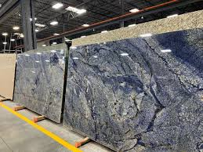** **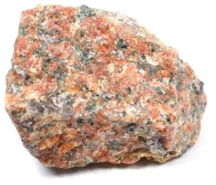**

**Granite**  is a coarse-grained ([phaneritic](https://en.wikipedia.org/wiki/Phanerite" \o "Phanerite)) [intrusive](https://en.wikipedia.org/wiki/Intrusive_rock) [igneous rock](https://en.wikipedia.org/wiki/Igneous_rock) composed mostly of [quartz](https://en.wikipedia.org/wiki/Quartz), [alkali feldspar](https://en.wikipedia.org/wiki/Alkali_feldspar), and [plagioclase](https://en.wikipedia.org/wiki/Plagioclase). It forms from [magma](https://en.wikipedia.org/wiki/Magma) with a high content of [silica](https://en.wikipedia.org/wiki/Silica) and [alkali metal oxides](https://en.wikipedia.org/wiki/Alkali_metal_oxide) that slowly cools and solidifies underground. It is common in the [continental crust](https://en.wikipedia.org/wiki/Continental_crust) of Earth, where it is found in [igneous intrusions](https://en.wikipedia.org/wiki/Igneous_intrusion). These range in size from [dikes](https://en.wikipedia.org/wiki/Dike_(geology)) only a few centimeters across to [batholiths](https://en.wikipedia.org/wiki/Batholith) exposed over hundreds of square kilometers.

Granite is typical of a larger family of *granitic rocks*, or *[granitoids](https://en.wikipedia.org/wiki/Granitoid" \o "Granitoid)*, that are composed mostly of coarse-grained quartz and feldspars in varying proportions. These rocks are classified by the relative percentages of quartz, alkali feldspar, and plagioclase (the [QAPF classification](https://en.wikipedia.org/wiki/QAPF_diagram)), with true granite representing granitic rocks rich in quartz and alkali feldspar. Most granitic rocks also contain [mica](https://en.wikipedia.org/wiki/Mica) or [amphibole](https://en.wikipedia.org/wiki/Amphibole) minerals, though a few (known as [leucogranites](https://en.wikipedia.org/wiki/Leucogranite" \o "Leucogranite)) contain almost no dark minerals.

Granite is nearly always massive (lacking any internal structures), hard, and tough. These properties have made granite a widespread construction stone throughout human history.

### Physical properties[[edit](https://en.wikipedia.org/w/index.php?title=Granite&action=edit&section=2" \o "Edit section: Physical properties)]

The average [density](https://en.wikipedia.org/wiki/Density) of granite is between 2.65 and 2.75 g/cm3 (165 and 172 lb/cu ft),[[10]](https://en.wikipedia.org/wiki/Granite#cite_note-10) its [compressive strength](https://en.wikipedia.org/wiki/Compressive_strength) usually lies above 200 MPa, and its [viscosity](https://en.wikipedia.org/wiki/Viscosity) near [STP](https://en.wikipedia.org/wiki/Standard_conditions_for_temperature_and_pressure) is 3–6·1020 Pa·s.[[11]](https://en.wikipedia.org/wiki/Granite#cite_note-11)

The melting temperature of dry granite at ambient pressure is 1215–1260 °C (2219–2300 °F);[[12]](https://en.wikipedia.org/wiki/Granite#cite_note-12) it is strongly reduced in the presence of water, down to 650 °C at a few hundred megapascals of pressure.[[13]](https://en.wikipedia.org/wiki/Granite#cite_note-13)

Granite has poor primary [permeability](https://en.wikipedia.org/wiki/Permeability_(earth_sciences)) overall, but strong secondary permeability through cracks and fractures if they are present.

### Chemical composition[[edit](https://en.wikipedia.org/w/index.php?title=Granite&action=edit&section=3" \o "Edit section: Chemical composition)]

A worldwide average of the chemical composition of granite, by weight percent, based on 2485 analyses:[[14]](https://en.wikipedia.org/wiki/Granite" \l "cite_note-blatt-tracy-66-14)

|  |  |  |  |
| --- | --- | --- | --- |
| SiO2 | 72.04% (silica) | TiO2 | 0.30% |
| Al2O3 | 14.42% (alumina) | P2O5 | 0.12% |
| K2O | 4.12% | MnO | 0.05% |
| Na2O | 3.69% | Fe2O3 | | | 1.22% |
| CaO | 1.82% | MgO | | | 0.71% |
| FeO | 1.68% |
|  |  |
| *GRAVEL* |  |

**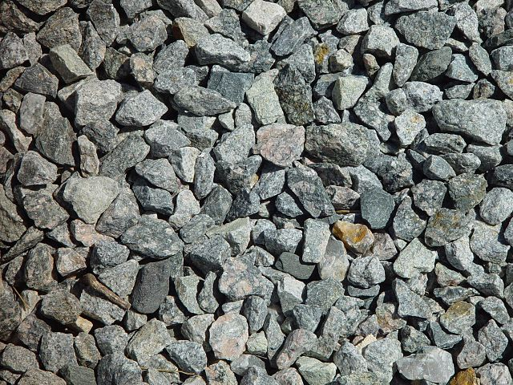** **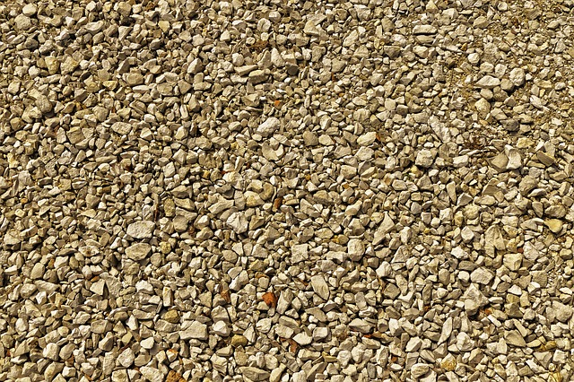**

**Gravel**  is a loose aggregation of rock fragments. Gravel occurs naturally throughout the world as a result of sedimentary and erosive geologic processes; it is also produced in large quantities commercially as crushed stone.

Gravel is classified by particle size range and includes size classes from [granule](https://en.wikipedia.org/wiki/Granule_(geology))- to [boulder](https://en.wikipedia.org/wiki/Boulder)-sized fragments. In the Udden-Wentworth scale gravel is categorized into granular gravel (2–4 mm or 0.079–0.157 in) and pebble gravel (4–64 mm or 0.2–2.5 in). ISO 14688 grades gravels as fine, medium, and coarse, with ranges 2–6.3 mm to 20–63 mm. One cubic metre of gravel typically weighs about 1,800 kg (or a cubic yard weighs about 3,000 lb).

Gravel is an important commercial product, with a number of applications. Almost half of all gravel production is used as aggregate for concrete. Much of the rest is used for road construction, either in the road base or as the road surface (with or without asphalt or other binders.) Naturally occurring porous gravel deposits have a high hydraulic conductivity, making them important aquifers.

## Production and uses

Gravel is a major basic raw material in [construction](https://en.wikipedia.org/wiki/Construction).[[24]](https://en.wikipedia.org/wiki/Gravel#cite_note-Bolen-24) Sand is not usually distinguished from gravel in official statistics, but [crushed stone](https://en.wikipedia.org/wiki/Crushed_stone) is treated as a separate category. In 2020, sand and gravel together made up 23% of all industrial mineral production in the U.S., with a total value of about $12.6 billion. Some 960 million tons of construction sand and gravel were produced. This greatly exceeds production of industrial sand and gravel (68 million tons), which is mostly sand rather than gravel.[[25]](https://en.wikipedia.org/wiki/Gravel#cite_note-USGS-25)

It is estimated that almost half of construction sand and gravel is used as [aggregate](https://en.wikipedia.org/wiki/Construction_aggregate) for [concrete](https://en.wikipedia.org/wiki/Concrete). Other important uses include in road construction, as road base or in [blacktop](https://en.wikipedia.org/wiki/Blacktop); as construction fill; and in myriad minor uses.[[24]](https://en.wikipedia.org/wiki/Gravel#cite_note-Bolen-24)

Gravel is widely and plentifully distributed, mostly as river deposits, river flood plains, and glacial deposits, so that environmental considerations and quality dictate whether alternatives, such as [crushed stone](https://en.wikipedia.org/wiki/Crushed_stone), are more economical. Crushed stone is already displacing natural gravel in the eastern United States, and recycled gravel is also becoming increasingly important.

Types of gravel include:

* ***Bank gravel***: naturally deposited gravel intermixed with sand or [clay](https://en.wikipedia.org/wiki/Clay) found in and next to rivers and streams. Also known as "bank run" or "river run".[[28]](https://en.wikipedia.org/wiki/Gravel#cite_note-FOOTNOTEJackson1997%22bank_gravel%22-28)
* ***Bench gravel***: a bed of gravel located on the side of a valley above the present stream bottom, indicating the former location of the stream bed when it was at a higher level. The term is most commonly used in [Alaska](https://en.wikipedia.org/wiki/Alaska) and the [Yukon Territory](https://en.wikipedia.org/wiki/Yukon_Territory).[[29]](https://en.wikipedia.org/wiki/Gravel#cite_note-FOOTNOTEJackson1997%22bench_gravel%22-29)
* [***Crushed stone***](https://en.wikipedia.org/wiki/Crushed_stone): rock crushed and graded by screens and then mixed to a blend of stones and fines. It is widely used as a surfacing for roads and driveways, sometimes with [tar](https://en.wikipedia.org/wiki/Tar) applied over it. Crushed stone may be made from [granite](https://en.wikipedia.org/wiki/Granite), [limestone](https://en.wikipedia.org/wiki/Limestone), [dolomite](https://en.wikipedia.org/wiki/Dolomite_(rock)), and other rocks. Also known as "crusher run", DGA (dense grade aggregate) QP (quarry process), and shoulder stone.[[30]](https://en.wikipedia.org/wiki/Gravel#cite_note-30) Crushed stone is distinguished from gravel by the U.S. Geological Survey.[[25]](https://en.wikipedia.org/wiki/Gravel#cite_note-USGS-25)
* ***Fine gravel***: gravel consisting of particles with a diameter of 2 to 6.3 millimetres (0.079 to 0.248 in)[[13]](https://en.wikipedia.org/wiki/Gravel#cite_note-ISO-13)
* [***Stone dust***](https://en.wikipedia.org/wiki/Stone_dust): fine, crushed, gravel from the final stage of screen separation, such that the gravel is not separated out from fine dust particles. As with other forms of crushed stone, this is distinguished from gravel by the U.S. Geological Survey.[[25]](https://en.wikipedia.org/wiki/Gravel#cite_note-USGS-25)
* [***Lag gravel***](https://en.wikipedia.org/wiki/Lag_deposit): a surface accumulation of coarse gravel produced by the removal of finer particles.
* [***Pay gravel***](https://en.wikipedia.org/wiki/Pay_gravel): also known as "pay dirt"; a nickname for gravel with a high concentration of gold and other precious metals. The metals are recovered through [gold panning](https://en.wikipedia.org/wiki/Gold_panning).
* ***Pea gravel***: also known as "pea shingle" is clean gravel similar in size to garden [peas](https://en.wikipedia.org/wiki/Peas).[[31]](https://en.wikipedia.org/wiki/Gravel#cite_note-FOOTNOTEJackson1997%22pea_gravel%22-31) Used for concrete surfaces, walkways, driveways and as a substrate in home aquariums.
* ***Piedmont gravel***: a coarse gravel carried down from high places by mountain streams and deposited on relatively flat ground, where the water runs more slowly.[[32]](https://en.wikipedia.org/wiki/Gravel#cite_note-FOOTNOTEJackson1997%22piedmont_gravel%22-32)
* ***Plateau gravel***: a layer of gravel on a plateau or other region above the height at which stream-terrace gravel is usually found.

*Timber*

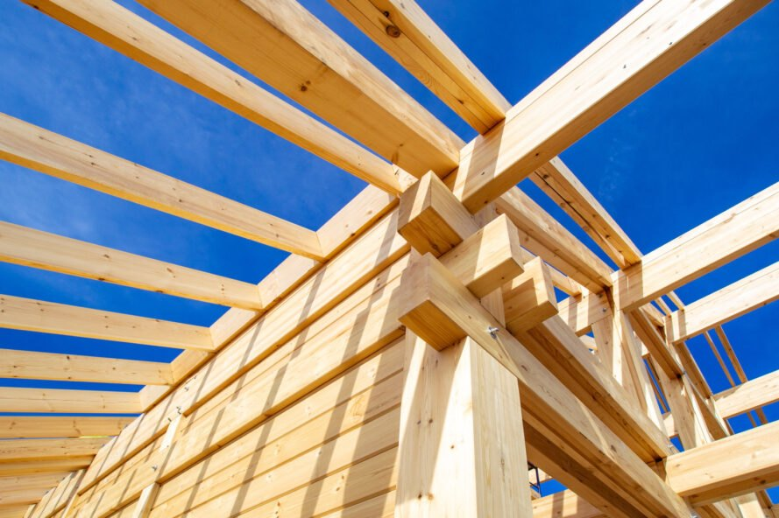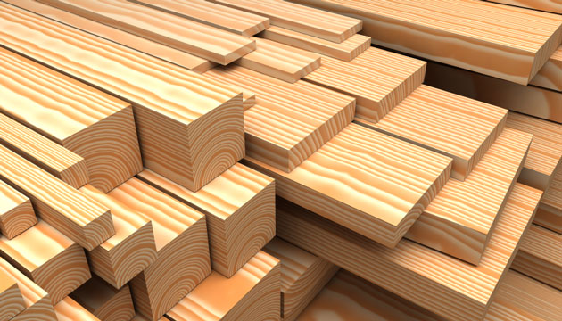  
Timber is one of the most useful and important material for constructions. Selecting timber is not an easy task, because timber has different types out of which selecting the right material is an important key. Timber is an expensive material to be incorporated in a building for different purpose therefore it should necessarily be strong, tough and durable. Timber doors or windows and etc. contribute a lot in the beautification and overall look of interiors. Timber is used in doors, windows, cabinet, cupboards, shelves, tables and railings etc. Timber is also popularly used in the form of plywood & raw wood. Products like ply blocks and ply boards. Heavy patterned doors and windows are made of solid wood/Timber to provide the strength, toughness and durability.

Type of timber to be used for right purpose is important because if timber used in construction is of low quality then this may need replacement. While selecting timber one should consider its quality aspect as timber must be free from decay like rotten, fungi and termite. Following are some essential tips and guidelines to know about timber selection for buildings:

* Teakwood is a most appropriate timber to be used in the construction of buildings. Teakwood is naturally durable with good merit and adaptability although it is prone to attacks of white ants and insects. Yet builders choose teakwood for its natural look, durability with long lasting characteristics.
* Sal is another timber material identified as much stronger and quite harder than teakwood used in building purposes. Sal is less prone to termite or fungi attack and can be used for several constructive purposes.
* Deodar is one of a strongest Indian conifer with less strength and weight than teakwood. Deodar has maintained its good image for durability and style of appearance. Deodar can be easily cast in any shape, easy to saw. Generally used for building & construction in homes and other civil structures.
* Hardwood is another form of wood which is treated thoroughly before use as it is not durable as much as teakwood or deodar. After treated through, wood preservative and polishing on hardwood makes it suitable for house building structure.
* Ply board is used in buildings for various purposes. They are formed by pressing together several layers of wood.
* Particle board is made of agro waste, cellulose etc and blended with adhesive to make into a solid board.

# Elements of Civil Engineering

# Assignment – 1

*NAME* : VAIBHAV C

*SR.NO* : 21-1120

*BRANCH & SEC* : AIML (P-2)

*TOPIC* : BUILDING MATERIALS